Name: Date:
Advanced Algebra
  - Lines in the Plane and Slope
The simplest mathematics model for relating two variables in the linear equation $y=mx+b$. The equation is called linear because its graph is a line and has a constant rate of change called slope.
What does the m represent in the equation $y=mx+b$?
What does the b represent in the equation $y=mx+b$?

The slope of a non vertical line is the number of units the line rises (or falls) vertically for each unit of horizontal change from left to right.
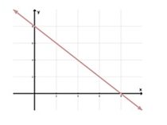
Slope Slope
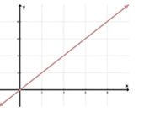

WAYS TO FIND SLOPE
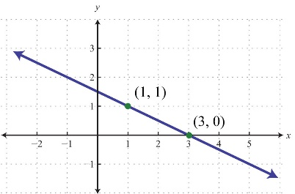
On the Graph In an equation Using the formula
$y= \frac{2}{3}x+5$ $m= \frac{y_{2}-y_{1}}{x_{2}-x_{1}}$
(6, 5) and (-1, 3)

Practice: Find the slope of the line for the following set of linear representations

1) Two points: $(-3, -2), (1, 6)$

2) Equation: $y=6-3x$

3) On a graph:
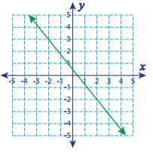

4) On a graph:
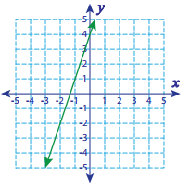

OTHER TYPES OF SLOPE
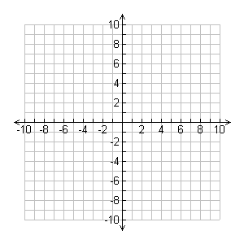
Zero Slope Undefined (No) Slope

Parallel Lines Perpendicular Lines

GRAPHING LINEAR EQUATION ON A COORDINATE PALNE
Example 1: On the graph below sketch the graph of the equation$y=3x+1$.
Use the table of values below to help create the graph. You may use arithmetic or your calculator.
$$x$$
$$y$$

With this method, you construct a table of values that consists of several solutions of this equation.
What about the equation helps you determine the look of the graph?

Example 2: On the graph below sketch the graph of the equation$y=x^{2}-1$.
Use the table of values below to help create the graph. You may use arithmetic or your calculator.
$$x$$
$$y$$

The graph of this equation is a __________________________.
What about the equation helps you determine the look of the graph?

Example 3: On the graph below sketch the graph of the equation $y= -\frac{1}{2}x-3$ without the use of a calculator.
Determine what you need to know to graph a line?

Find the information needed and list it below.

Practice: Graph the linear equations below on the given set of axes.

1) $y= \frac{2}{3}x-1$

2) $y=3x$

3) $y=5-2x$

4) $y= -\frac{1}{4}x+3$

